**Number Systems Used In Computers**

Complete the following table:

|  |  |  |  |
| --- | --- | --- | --- |
| **Number System** | **Number Base** | **Digits Used** | **Purpose** |
| Decimal | Base 10 | 0 to 9 | Used for communicating with human users |
| Binary |  |  |  |
| Octal |  |  |  |
| Hexadecimal |  |  |  |

**Decimal vs. Binary System**

Write down the definition of a **Bit** in computer terminology:

Complete the following table:

|  |  |  |
| --- | --- | --- |
|  | **Decimal System** | **Binary System** |
| Uses Digits |  |  |
| Addition Examples |  |  |
| Powers of 10 |  |  |
| Evaluate 111 |  |  |

**Powers of 2**

|  |  |  |  |  |
| --- | --- | --- | --- | --- |
| **Power  of 2** | **Decimal Value** | **Integer Range** | **Number  of Bits** | **Computer Binary** |
| 21 | 2 | 0 - 1 | 1 | 0001 |
| 22 | 4 | 0 - 3 | 2 | 0011 |
| 23 |  |  |  | 0111 |
| 24 |  |  |  | 1111 |
| 25 |  |  |  | 0001 1111 |
| 26 |  |  |  | 0011 1111 |
| 27 |  |  |  | 0111 1111 |
| 28 | 256 | 0 - 255 | 8 | 1111 1111 |
| 29 |  |  |  | 0001 1111 1111 |
| 210 |  |  |  | 0011 1111 1111 |
| 211 |  |  |  | 0111 1111 1111 |
| 212 |  |  |  | 1111 1111 1111 |
| 213 |  |  |  | 0001 1111 1111 1111 |
| 214 |  |  |  | 0011 1111 1111 1111 |
| 215 |  |  |  | 0111 1111 1111 1111 |
| 216 | 65,535 | 0 – 65,534 | 16 | 1111 1111 1111 1111 |

**Conversions**

Convert the following binary numbers to decimal:

11 binary =

101 binary =

1010 binary =

Convert the following decimal numbers to binary:

6 decimal =

13 decimal =

**Binary Addition**

Add the following binary numbers. (verify your answers using decimal)

|  |  |  |  |  |  |  |  |  |  |  |  |  |  |
| --- | --- | --- | --- | --- | --- | --- | --- | --- | --- | --- | --- | --- | --- |
| |  |  | | --- | --- | | **0101** | **(decimal 5)** | | **+ 0010** | **(decimal 2)** | |  |  | | |  |  | | --- | --- | | **0101** | **(decimal 5)** | | **+ 1010** | **(decimal 10)** | |  |  | |
| |  |  | | --- | --- | | **0011** | **(decimal 3)** | | **+ 0010** | **(decimal 2)** | |  |  | | |  |  | | --- | --- | | **0110** | **(decimal 6)** | | **+ 0011** | **(decimal 3)** | |  |  | |

**Prefixes**

* Kilo (K) means __________________ Multiply by x______________
* Mega (M) means _________________ Multiply by x______________

* Giga (G) means __________________ Multiply by x______________
* Tera (T) means __________________ Multiply by x______________

**Examples**

1. 64 Kbps (Kilo-bits per seconds) = ___________________ bps (bits per second)
2. 256 Giga-bytes = _________________________________ bytes
3. 256 Giga-bytes = _________________________________ bits

**Computer Memory Structures**

|  |  |  |  |
| --- | --- | --- | --- |
| **Structure** | **Number of Bits** | **Largest Value** | **Used For...** |
| Bit |  |  |  |
| Byte |  |  |  |
| Word |  |  |  |
| Short Integer |  |  |  |
| Double Word |  |  |  |
| Long Integer |  |  |  |
| Memory Address |  |  |  |

**Memory Organization**

Bit (Binary Digit)

* One bit can have a value of ________ or _________
* Or a Boolean logic value of ________ or _________

|  |  |  |  |  |  |  |  |  |  |  |  |  |  |  |  |  |  |  |  |
| --- | --- | --- | --- | --- | --- | --- | --- | --- | --- | --- | --- | --- | --- | --- | --- | --- | --- | --- | --- |
| |  |  |  |  | | --- | --- | --- | --- | | 0 | 0 | 0 | 0 | | |  |  |  |  | | --- | --- | --- | --- | | 0 | 0 | 0 | 0 | | |  |  |  |  | | --- | --- | --- | --- | | 0 | 0 | 0 | 0 | | |  |  |  |  | | --- | --- | --- | --- | | 0 | 0 | 0 | 0 | |

Byte (8 bits)

* One byte has a size of ________ bits
* A byte has an unsigned integer value range from 0 to _________

|  |  |  |  |  |  |  |  |  |  |  |  |  |  |  |  |  |  |  |  |
| --- | --- | --- | --- | --- | --- | --- | --- | --- | --- | --- | --- | --- | --- | --- | --- | --- | --- | --- | --- |
| |  |  |  |  | | --- | --- | --- | --- | | 0 | 0 | 0 | 0 | | |  |  |  |  | | --- | --- | --- | --- | | 0 | 0 | 0 | 0 | | |  |  |  |  | | --- | --- | --- | --- | | 0 | 0 | 0 | 0 | | |  |  |  |  | | --- | --- | --- | --- | | 0 | 0 | 0 | 0 | |

Word (2 bytes or 16 bits)

* One word has a size of ________ bits
* One word has a size of ________ bytes
* A byte has an unsigned integer value range from 0 to _________

|  |  |  |  |  |  |  |  |  |  |  |  |  |  |  |  |  |  |  |  |
| --- | --- | --- | --- | --- | --- | --- | --- | --- | --- | --- | --- | --- | --- | --- | --- | --- | --- | --- | --- |
| |  |  |  |  | | --- | --- | --- | --- | | 0 | 0 | 0 | 0 | | |  |  |  |  | | --- | --- | --- | --- | | 0 | 0 | 0 | 0 | | |  |  |  |  | | --- | --- | --- | --- | | 0 | 0 | 0 | 0 | | |  |  |  |  | | --- | --- | --- | --- | | 0 | 0 | 0 | 0 | |
|  | |  | |

Long or Double Word (4 bytes or 32 bits)

* One Long word has a size of ________ words
* A Long word has an unsigned integer value range from 0 to _________

|  |  |  |  |  |  |  |  |  |  |  |  |  |  |  |  |  |  |  |  |
| --- | --- | --- | --- | --- | --- | --- | --- | --- | --- | --- | --- | --- | --- | --- | --- | --- | --- | --- | --- |
| |  |  |  |  | | --- | --- | --- | --- | | 0 | 0 | 0 | 0 | | |  |  |  |  | | --- | --- | --- | --- | | 0 | 0 | 0 | 0 | | |  |  |  |  | | --- | --- | --- | --- | | 0 | 0 | 0 | 0 | | |  |  |  |  | | --- | --- | --- | --- | | 0 | 0 | 0 | 0 | |
|  | |  | |
| |  |  |  |  | | --- | --- | --- | --- | | 0 | 0 | 0 | 0 | | |  |  |  |  | | --- | --- | --- | --- | | 0 | 0 | 0 | 0 | | |  |  |  |  | | --- | --- | --- | --- | | 0 | 0 | 0 | 0 | | |  |  |  |  | | --- | --- | --- | --- | | 0 | 0 | 0 | 0 | |
|  | |  | |

**Questions**

1. What is the smallest memory object that can represent a character of information?
   1. Think… How many upper case letters in the alphabet (A to Z)? 26
   2. Think… How many lower case letters in the alphabet (a to z)? 26
   3. Think… How many number digits (0 to 9)? 10
   4. Think… How many punctuation marks? 14
   5. Add them all up. 76
2. Research the ASCII characters set. What is it and how is it related to computer memory?  
   It uses decimal data to turn hex data into character data (e.g. Dec: 33 = Hex: 21 = Character Text: !)

This is how text is shown on computer screens, the text is written down, then when sent, gets turned into a hex number, then once a message is received, the hex is turned into an actual character which creates text. Also, an Ascii Character can take up to a 1-127 bits.

1. How are strings of characters (Google “String”) represented in computer memory?

Strings are a line of text or a line of words, which traditionally are withheld via the use of numbers in a computer, depending on the size of bits and what type of memory structure you are using, they can be displayed in multiple forms.

1. How are negative integers represented in computer memory? (Include a diagram)  
   The opposite digits as the positive number will be placed (1 = 0000 0001 compared to -1 = 1111 1110).

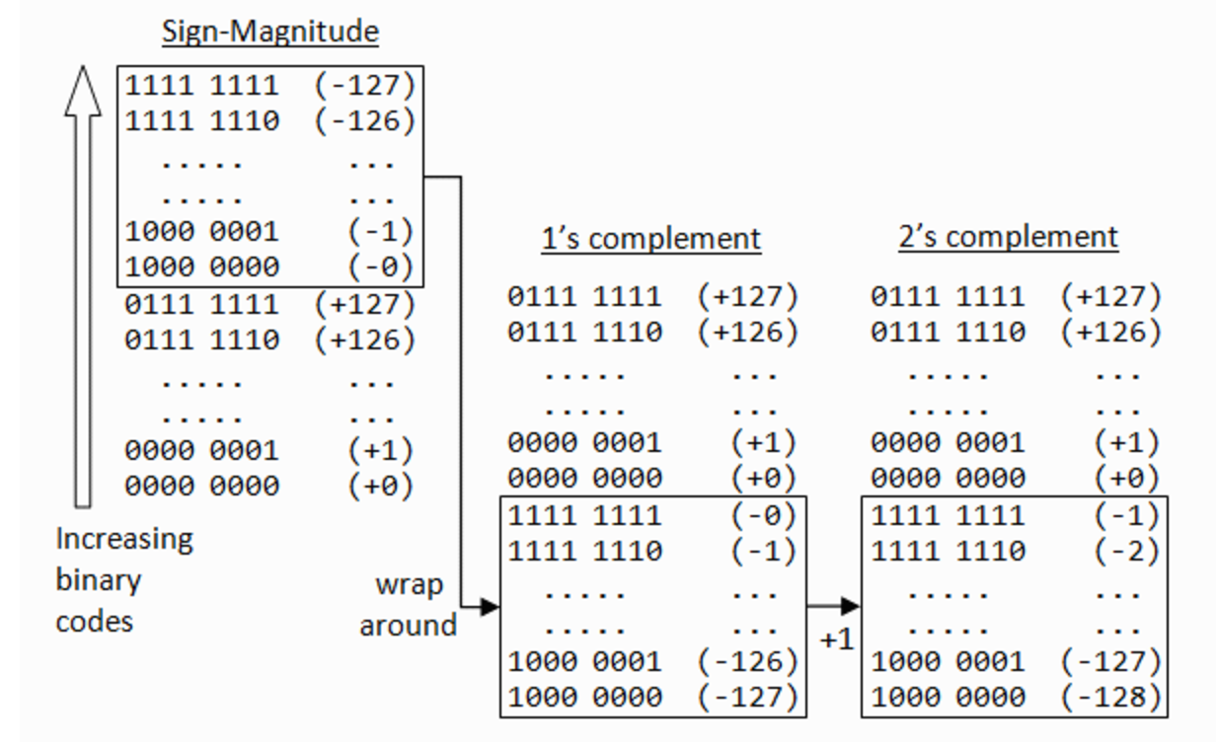

1. How are decimal numbers (Google “Floating Point”) represented in computer memory? (Include a diagram)

It is an assumed answer created via the use of attempting to solve an equation.

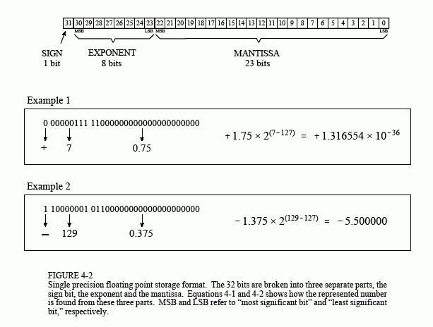

1. A Pixel is computer memory structure used to store image information. How is a Pixel represented in memory? (Include a diagram).

A pixel is represented by 8 bits and a rgb scale which tells what a pixel is and how to act like that type of pixel.